Egypt, Arab Rep.

## Political Stability Estimate Data

The data set shows the political stability estimate of the country each year.

## # A tibble: 19 x 5  
## country iso3c date stability stabilityCategory4   
## <chr> <chr> <dbl> <dbl> <chr>   
## 1 Egypt, Arab Rep. EGY 1996 -0.524 moderately unstable  
## 2 Egypt, Arab Rep. EGY 1998 -0.0185 moderately unstable  
## 3 Egypt, Arab Rep. EGY 2000 0.0531 moderately stable   
## 4 Egypt, Arab Rep. EGY 2002 -0.413 moderately unstable  
## 5 Egypt, Arab Rep. EGY 2003 -0.640 moderately unstable  
## 6 Egypt, Arab Rep. EGY 2004 -0.822 moderately unstable  
## 7 Egypt, Arab Rep. EGY 2005 -0.630 moderately unstable  
## 8 Egypt, Arab Rep. EGY 2006 -0.839 moderately unstable  
## 9 Egypt, Arab Rep. EGY 2007 -0.551 moderately unstable  
## 10 Egypt, Arab Rep. EGY 2008 -0.511 moderately unstable  
## 11 Egypt, Arab Rep. EGY 2009 -0.607 moderately unstable  
## 12 Egypt, Arab Rep. EGY 2010 -0.898 moderately unstable  
## 13 Egypt, Arab Rep. EGY 2011 -1.44 highly unstable   
## 14 Egypt, Arab Rep. EGY 2012 -1.44 highly unstable   
## 15 Egypt, Arab Rep. EGY 2013 -1.64 highly unstable   
## 16 Egypt, Arab Rep. EGY 2014 -1.63 highly unstable   
## 17 Egypt, Arab Rep. EGY 2015 -1.50 highly unstable   
## 18 Egypt, Arab Rep. EGY 2016 -1.44 highly unstable   
## 19 Egypt, Arab Rep. EGY 2017 -1.42 highly unstable

## Political Stability Estimate Plot

The plot shows the trends of stabilization and destabilization for the each country.

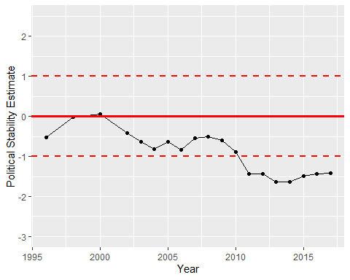

Political Stability Trend